**SOLUTION:**

double t_marks, ob_marks=0, per;

Console.Write( "enter no of couses: ");

int n = int.Parse(Console.ReadLine());

t_marks = n * 50;

string[] cou_name = new string[n];

double[] marks = new double[n];

for (int i = 0; i < n; i++)

{

Console.Write("enter course name: ");

cou_name[i] = Console.ReadLine();

Console.Write("enter marks : ");

marks[i] =double.Parse( Console.ReadLine());

ob_marks = ob_marks + marks[i];

}

Console.Clear();

Console.WriteLine("COURSE NAME \t\t MARKS\n");

for (int i = 0; i < n; i++)

{

Console.WriteLine(cou_name[i]+"\t\t"+marks[i]+"\n");

}

per = (ob_marks / t_marks) * 100;

Console.WriteLine("\nTOTAL MARKS: "+t_marks);

Console.WriteLine("OBTAINED MARKS: "+ ob_marks);

Console.WriteLine("PERCENTAGE {0}%", per);

**OUTPUT:**

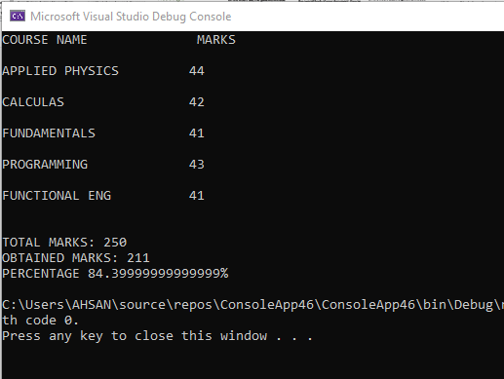

**SOLUTION:**

Console.Write("enter positive integer: ");

int n = Convert.ToInt32(Console.ReadLine());

int[] array = new int[n];

Console.WriteLine("enter series: ");

for (int i = 0; i < n; i++)

{

array[i] = Convert.ToInt32(Console.ReadLine());

}

bool symmetric = true;

for (int i = 0; i < array.Length/2; i++)

{

if (array[i]!=array[n-i-1])

{

symmetric = false;

break;

}

}

Console.WriteLine("series is syymetric {0}",symmetric);

**OUTPUT:**

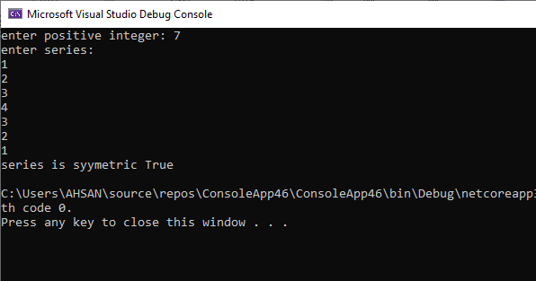

int n, m;

Console.Write("enter positive integer: ");

n = Convert.ToInt32(Console.ReadLine());

int[] array1 = new int[n];

Console.WriteLine("enter series for array 1: ");

for (int i = 0; i < n; i++)

{

array1[i] = Convert.ToInt32(Console.ReadLine());

}

Console.Write("enter positive integer: ");

m = Convert.ToInt32(Console.ReadLine());

int[] array2 = new int[m];

Console.WriteLine("enter series for array 2: ");

for (int i = 0; i < m; i++)

{

array2[i] = Convert.ToInt32(Console.ReadLine());

}

int a = array1.Length;

int b = array2.Length;

Console.WriteLine("length of array 1 is "+ a);

Console.WriteLine("length of array 2 is "+ b);

if (a==b)

{

for (int i = 0; i < n; i++)

{

if (array1[i]==array2[i])

{

Console.WriteLine("BOTH ARRAYS ARE SAME IN LENGTH AND ELEMENTS");

}

else

{

Console.WriteLine("BOTH ARRAYS ARE SAME IN LENGTH BUT NOT IN ELEMENTS");

}

}

}

else

{

Console.WriteLine("LENGTH OF BOTH ARRAYS ARE NOT SAME");

}

**INCOME TAX**

**SOLUTION:**

Console.Write("enter no of months: ");

int n = int.Parse(Console.ReadLine());

double m_salary = 0, a_salary = 0,i_tax=0;

double comm=0;

string[,] salary = new string[n, 4];

for (int i = 0; i < n; i++)

{

Console.Write("enter your name: ");

salary[i, 0] = Console.ReadLine();

Console.Write("enter your basic salary of month {0}: ",i+1);

salary[i,1]=Console.ReadLine();

int b_sal = int.Parse(salary[i, 1]);

Console.Write("enter your monthly sale of month {0}: ", i + 1);

salary[i,2]=Console.ReadLine();

int m_sale = int.Parse(salary[i, 2]);

if (m_sale>=100000&&m_sale<250000)

{

Console.WriteLine("commision = 1.5%");

comm=m_sale*0.015;

}

else if (m_sale>=250000&&m_sale<500000)

{

Console.WriteLine("commision = 2 %");

comm = m_sale * 0.02;

}

else if (m_sale>=500000)

{

Console.WriteLine("commision = 2.5%");

comm = m_sale * 0.025;

}

m_salary = b_sal + comm ;

salary[i, 3] = m_salary.ToString();

a_salary += m_salary ;

Console.WriteLine("monthly salary of month {0}: {1}",i+1,m_salary);

}

Console.Clear();

Console.WriteLine("\nNAME \t\tB_SALARY \t M_SALE \t M_SALARY\n");

for (int i = 0; i < n; i++)

{

for (int j = 0; j < 4; j++)

{

Console.Write(salary[i,j]+"\t\t");

}

Console.WriteLine();

}

if (a_salary >= 200000 && a_salary < 300000)

{

Console.WriteLine("Income Tax = 6%");

i_tax = a_salary * 0.06;

}

if (a_salary >= 300000 && a_salary < 450000)

{

Console.WriteLine("Income Tax = 7.5%");

i_tax = a_salary * 0.075;

}

else if (a_salary >= 450000)

{

Console.WriteLine("Income Tax = 8%");

i_tax = a_salary * 0.08;

}

else

{

Console.WriteLine("\nNO tax b/c my annual salary is less then 200000");

}

Console.WriteLine("-------------------------------------------");

Console.WriteLine("\nannual salary: "+a_salary);

Console.WriteLine("INCOME TAX OF MY ANNUAL SALARY = {0}\n",i_tax);

Console.WriteLine("-------------------------------------------");